Software-Anforderungsspezifikation
Thema: Chatbot für die Programmierwerkstatt
Supervisor: Dr.-Ing. André Pomp
Autor: Nguyen Truong An
Duration: Two months – half time.
Version | Datum | Kommentar
0.1 | 05.05.2026 | Initialer Entwurf
0.5 | 20.05.2026
0.9 | 25.06.2026

I. General Document
1. System description
- The system provides a web-based, AI-powered assistant helping in tasks creation and evaluation.
- Unlike conventional chatbots, user interaction is not limited to direct answer generation but follows a guided interaction model. The configuration consists of system settings and user’s settings (The course owner)
- After user joins a course, they will create a personal profile that records their experiences and learning goals. This information will help create more personalized tasks as well as evaluation.

- The objective of this approach is to encourage independent problem-solving and adapt the system to different learning needs and preferences.
- The system is currently locked on having one chatbot, specifically for programming.
2. System description
•Frontend:
- React (UI)
- Fetch / Axios (API calls)
•Backend
- FastAPI (API layer)
- Uvicorn (Server)
AI-Integration
- LangChain
- LLM Model (inferenz-gpt-oss-120b)
Databank
- SQLLite
- SQLAlchemy (Enabling query in python syntax)
Configuration
- python-dotenv
Deployment
- GitHub (BUW)
2. Functional Requirements
• LF1: User Management
=> Registration, login, logout and token for login authentication.
• LF2: Profile/Course Management
=> Create, Search, Edit for chatbot
• LF3: Large Language Model Integration
=> Integration of LLM into the Generation of Goals, Task and Evaluation
• LF4: Control via Python Configuration
=> System behavior, constraints, and prompt logic are defined and managed on server-side using Python.
• LF5: Personal Educational Information Management
=> Allow User to edit their personal learning goals, proving useful information for better Generation mentioned in LF3.
• LF6: Educational Tasks
=> Chatbot will provide the user with either the default tasks defined by the owner or providing new relevant tasks and automatic evaluations of user’s input for its effectiveness on the learning Goals.
• LD-1: Data Storage
=> Storage of user login’s data, profile’s data like prompts settings, personal education data on enrolled courses. The history of user’s interaction with the chatbot, response, answer, task and evaluation.

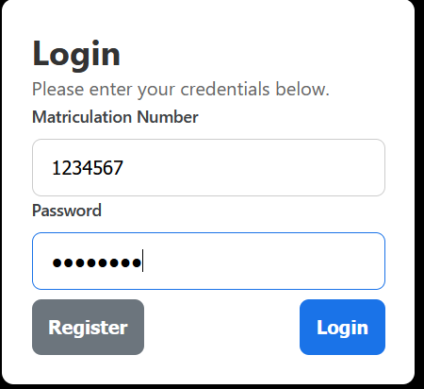
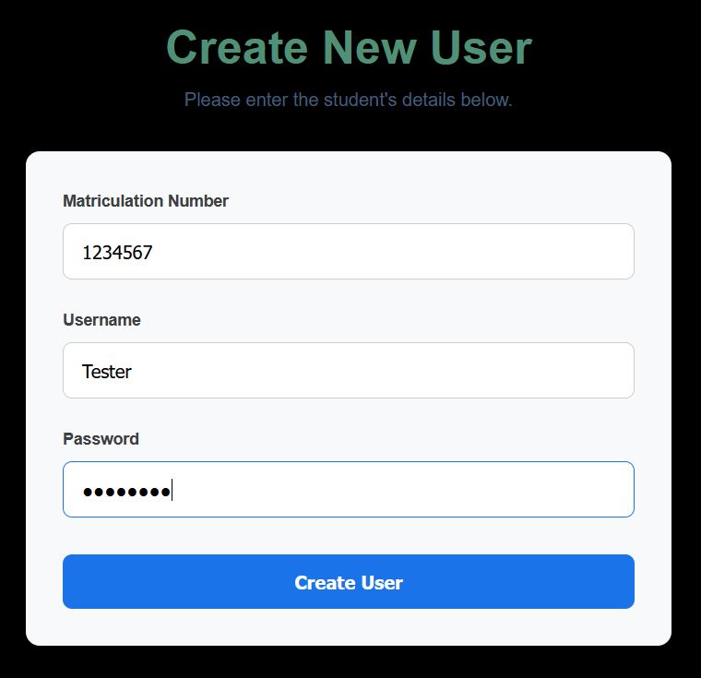

Define the chatbot
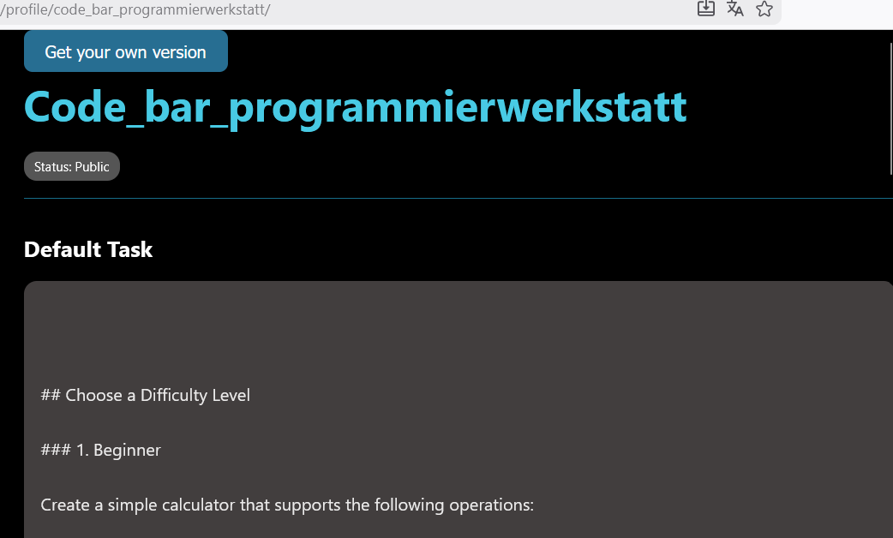
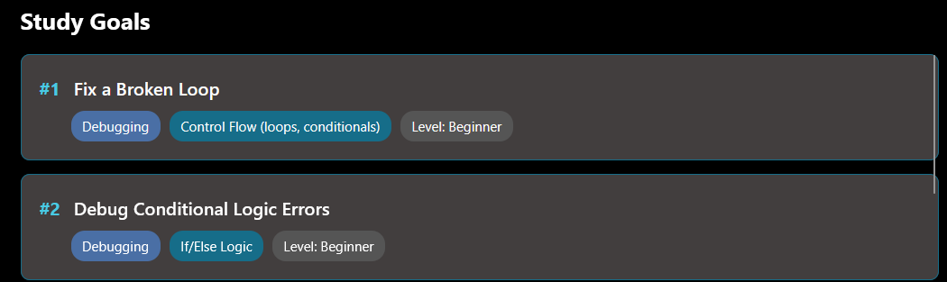

Interaction example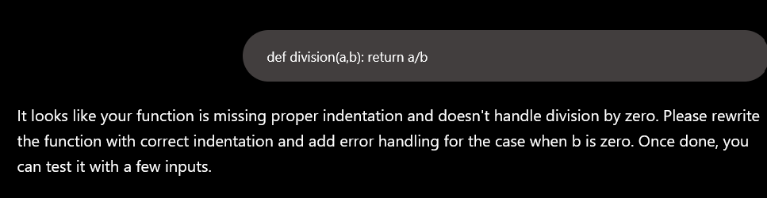

Select learning Goals
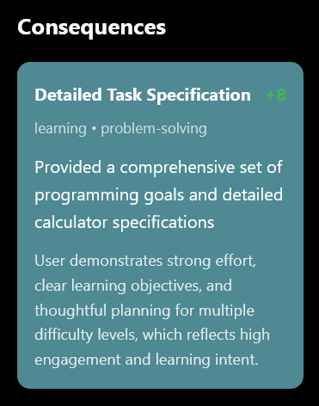
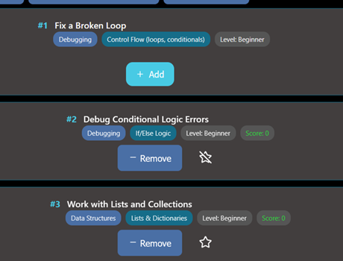

Get more personalized tasks by answering questions
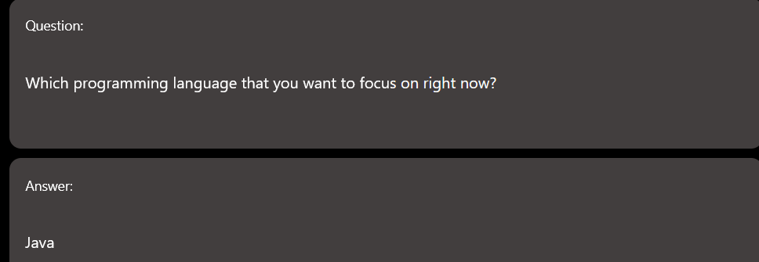
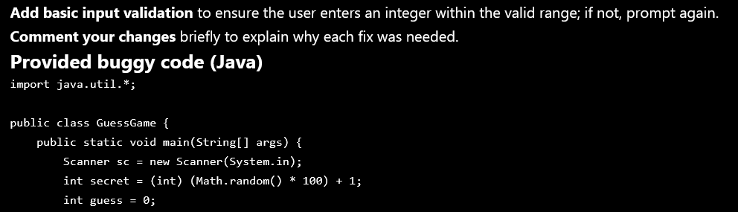

III. UML Diagram
1. Use Case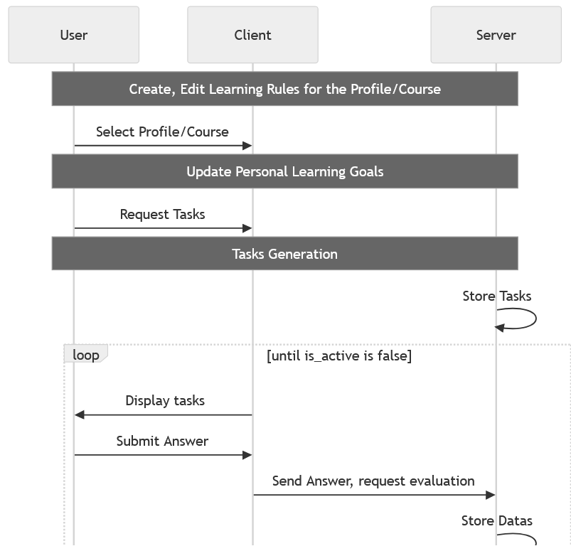
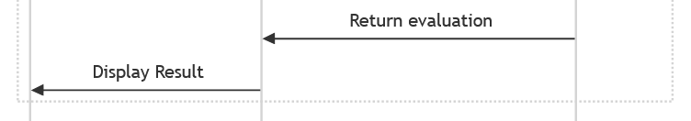

2. Backend Architect
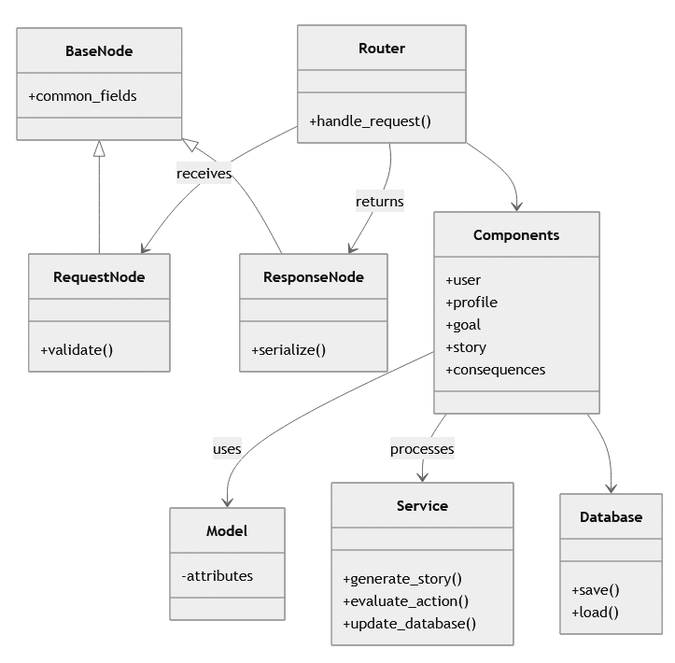

3. Frontend Architect
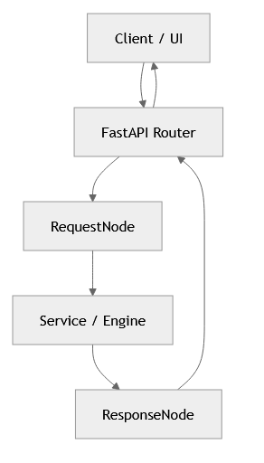
4. LLM Intergration
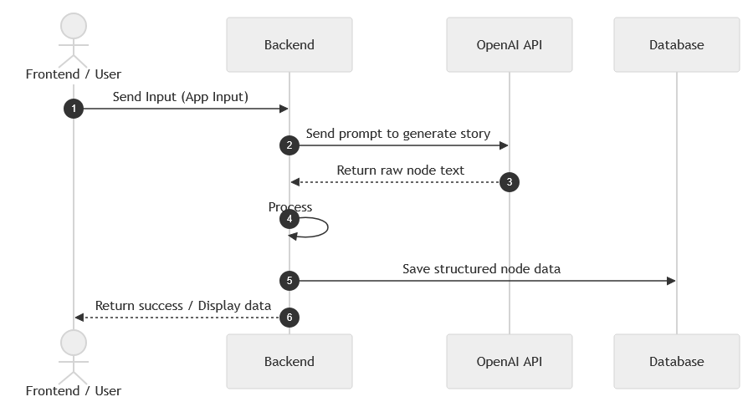

2. Backend Architect

III. Detailed Documentation
1. Fast API
a. API-Router – A class to structure the application in multiple files.
=> Instead of connecting into only one router. Clients will communicate with the server through many different routers for its specific purposes.
b. Depends - Creates relationship graphs.
i. Resolves all dependencies in the correct order.
ii. Caches results (no duplicate database queries).
iii. Centralizes errors handling.
c. Cookie(default=None)
=> Storing login token for authentication
d. Self-Document
=> FastAPI includes a
2. SQL Alchemy
a. Create engine
- Creates the database engine using the configured database settings and establishes connection

b. Event listener
- Enables SQLite foreign key constraint enforcement
(PRAGMAforeign_keys=ON) whenever a new database connection is
created.
c. Session maker
- Creates a session factory for data operations, allowing queries , transaction and track changes of the ORM (Object-Relational
Mapping) objects.
d. relationships function from ORM
- Establishes relational connection between tables. Enabling
shorter query using referral access even though the query speed
remain the same.
e. func,now() allows the engine to capture date time helps with
ordering rows in databank.

3. “pydantic”
=> The complication of unwanted columns or the need of changing
columns name temporarily in join operations asking for an alternative instead of using ORM object directly. With the help of pydantic base
model, we can create up to 3 schemas per operation.
a. Base Node:
=> Often, the request and response consist of
identical columns. Having same Base Node will reduce DRY-Code and guarantees that we only have one source of truth.
b. Request Node:
=> Instead of allowing clients to query the databank directly,
we define request-schemas to formalize request and protect the
server from bad operations.
c. Response Node:
=> Instead of displaying all the relevant information from the
databank. Frontend-Display will only ask for certain columns
Even though it is not prohibited to return all the information,
it’s better to have a dedicated response schemas to protect
business data.
4. Langchain
- Providing Chat prompt for communication with Language Model. Separating system prompt and user prompt.

